Client Side Results :

- For Valid Inputs (1 to 4) :

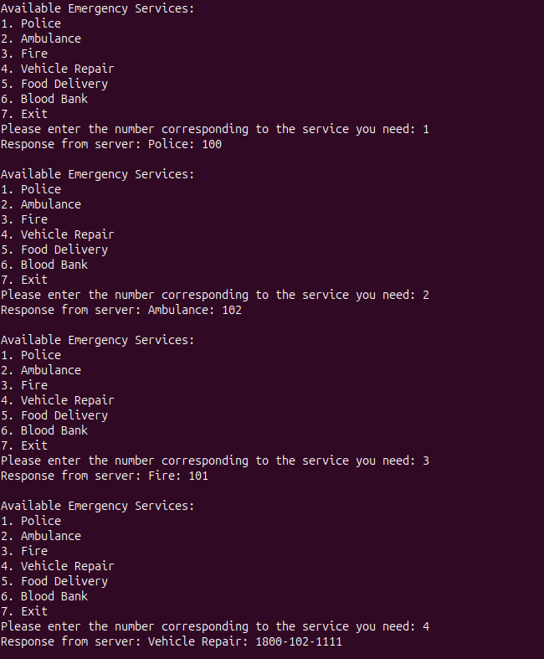

- For Valid Inputs (5 to 6) and Invalid Inputs :

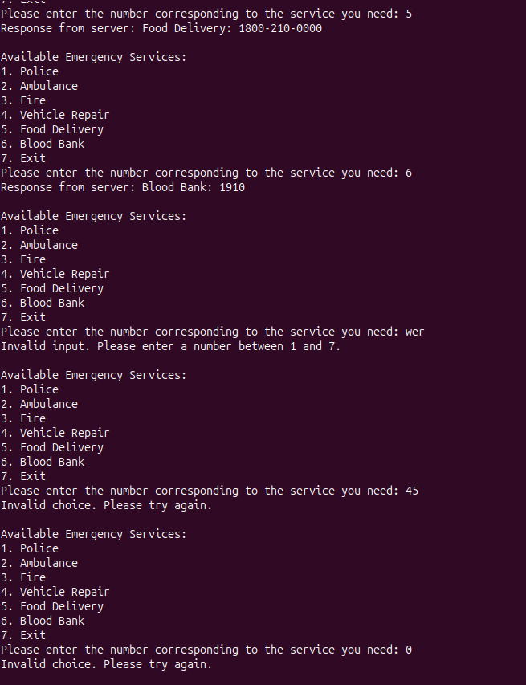

Server Side Results :

- Server Logs :

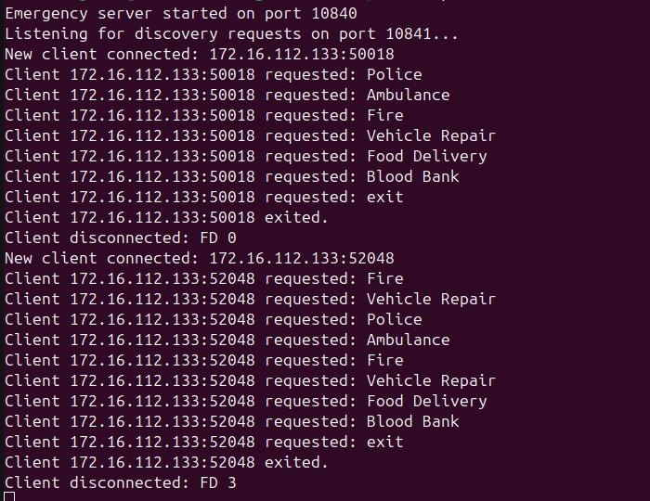

- CSV File Data Being Updated :
